Tutorial of BST and AVL Tree

1. BST
- Show the result of inserting 3, 1, 4, 2, 5, 6, 9, 7, 12, 8, 10, 13, 11 into an initially empty binary search tree.
Solution:
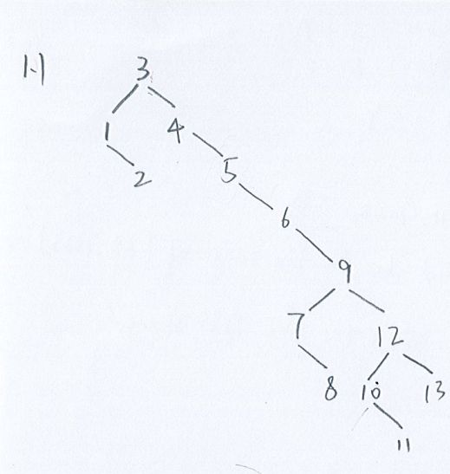
- Please write down the Inorder traversal of the BST
Solution:
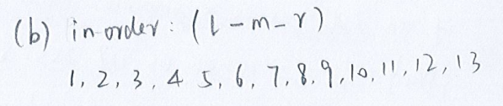
- Please write down the Preorder traversal of the BST
Solution:
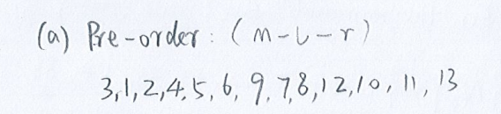
- Please write down the Postorder traversal of the BST
Solution:
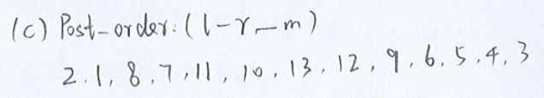
- Show the result of deleting of node “2”
- Show the result of deleting of node “5”
Solution:
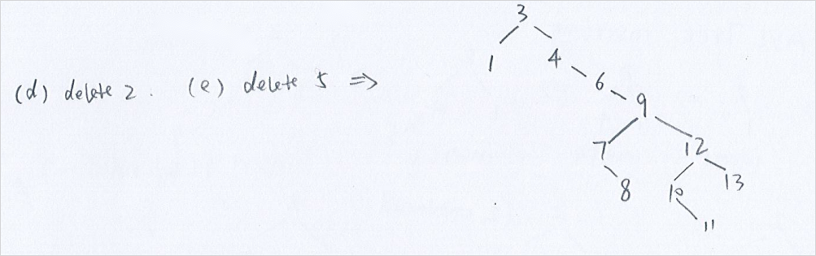
- Show the result of deleting of node “9”
Solution:
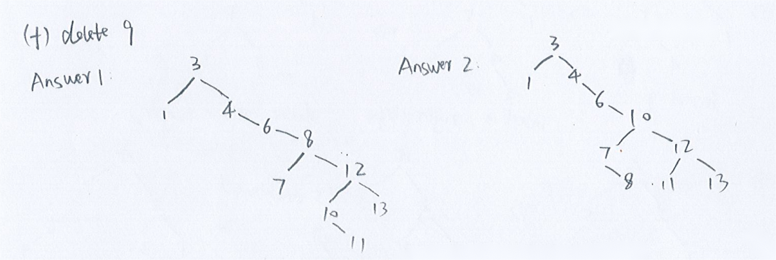
- A full node is a node with two children. Prove that the number of full nodes plus one is equal to the number of leaves in a nonempty binary search tree.
Solution:
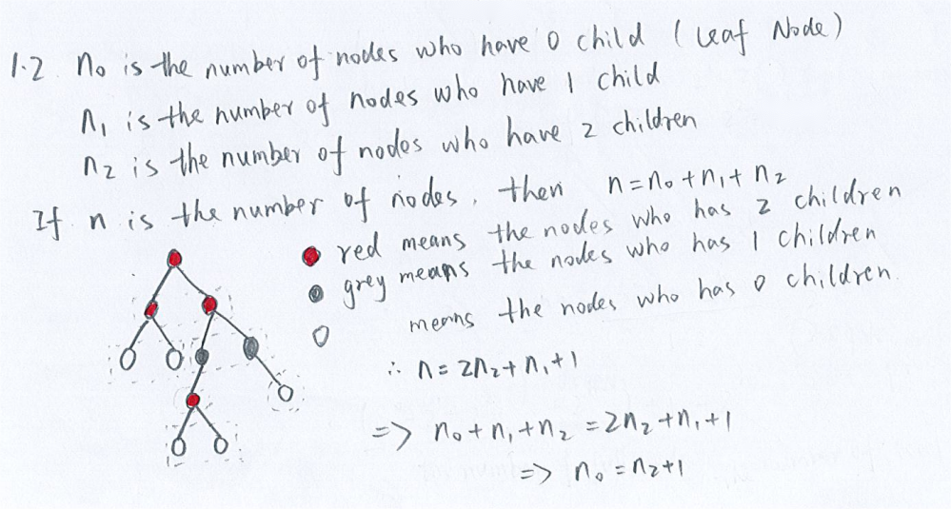
- What is the maximum and minimum height of a binary search tree with n node?
Solution:
maximum : $n−1$
minimum: $logn$
- What is the time complexity of Search, findMax, findMin, Insertion and Deletion of a binary search tree?
Solution:
O(tree height)

Best case: O($logn$)
Worst case: $O(n)$

2. AVL Tree
- What is the maximum AVL Tree height of 90 nodes?
Solution:
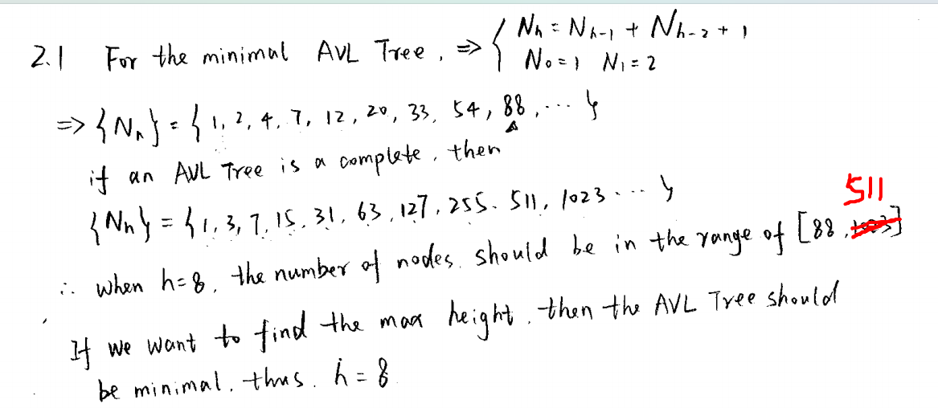
- Show the result of inserting 2, 1, 4, 5, 9, 3, 6, 7 into an initially empty AVL Tree.
Solution:

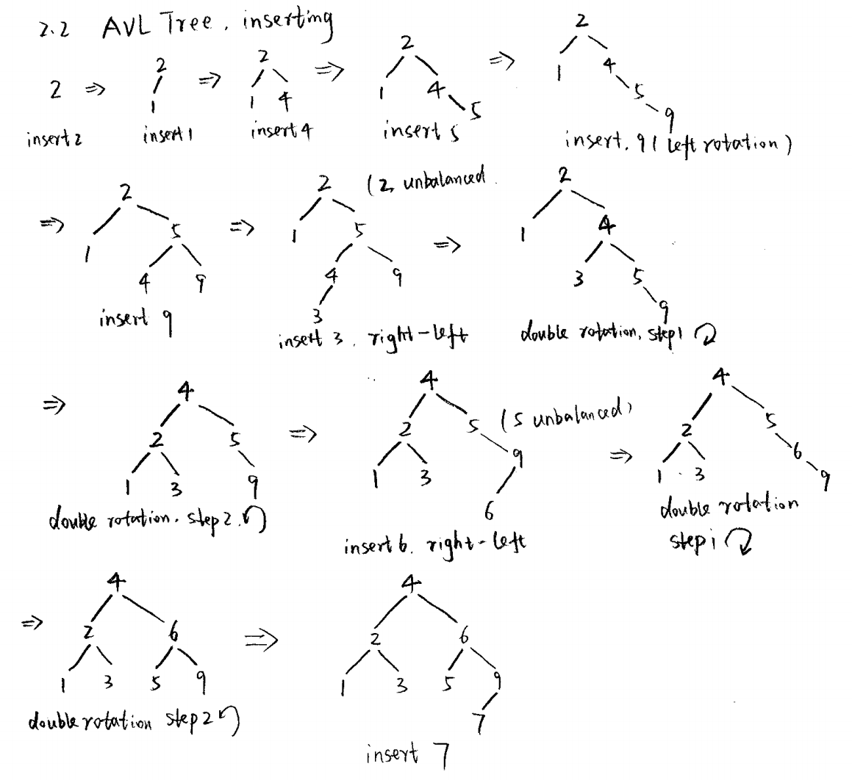
- Show the result of deleting node “1” and “3” from the AVL Tree in 2.2
Delete “1”:
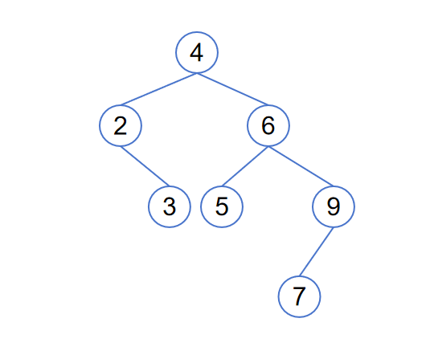
Delete “3”:
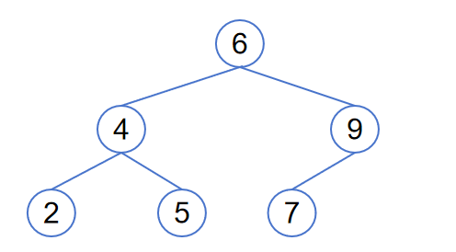
- Show the result of deleting root from the AVL Tree in 2.2
Method 1: Replace root with maximum node in the left subtree
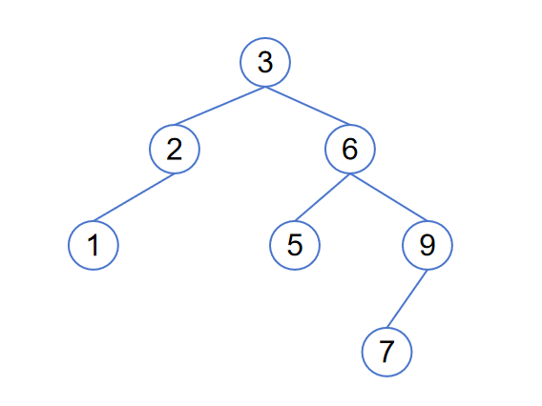
Method 2: Replace root with minimum node in the right subtree
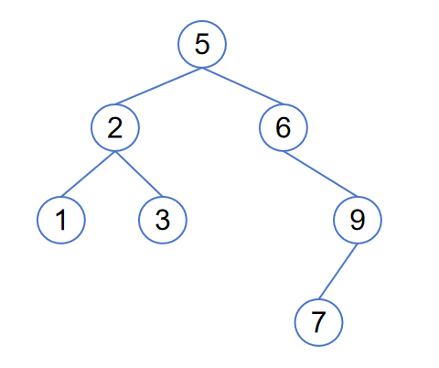

In this case node 6 is unbalanced, double rotation:
